Exceptions

  - User Guide

Insperity™, a trusted advisor to America’s best businesses for more than 26 years, provides an array of human resources and business solutions designed to help improve business performance.

Insperity and the compass icon, and the Inspiring Business Performance tagline are trademarks of Insperity, Inc.

Microsoft and Internet Explorer are registered trademarks of Microsoft Corporation in the United States and/or other countries.

Google and Chrome are trademarks of Google Inc.

Mozilla and Firefox are registered trademarks of the Mozilla Foundation.

The information contained in this document is subject to change without notice. Nothing in this document should be construed as constituting an additional warranty. Insperity shall not be liable for technical or editorial errors or omissions contained in this document.

Copyright © 2017 Insperity.
All Rights Reserved.

First Edition: January 2017

Contents
Introduction 3
Alerts 3
Navigating to the Alerts Page 3
Reviewing the Alerts Page 4
Alert Type Definitions 5
Resolving Alerts 6
Attendance 8
Navigating to the Attendance Page 8
Reviewing the Attendance Page 9
Attendance Detail Definitions 10
Editing an Attendance Record 10
Deleting an Attendance Record 11
Adding an Attendance Record 11
Attendance Calendar 12
Reviewing and Using the Attendance Calendar Page 13
Frequently Asked Questions 14
What is the difference between the Alerts and Attendance pages? 14
Is it possible to see all employees’ attendance information at once in the Attendance pages? 14

Introduction
The Exceptions section in Time and Attendance is used to track employee attendance. It consists of three pages: Alerts, Attendance, and Attendance Calendar. The alerts page tracks items that need attention from the user, while the Attendance and Attendance Calendar pages are used to track employee generated, attendance-specific alerts long-term. Access to each option is dependent on company set up.

Alerts
An alert is an item within the Time and Attendance system that needs attention from the user. Many of the alerts are generated from employee timekeeping. The required action by the user(s) is determined by the type of alert.

Navigating to the Alerts Page
- In the Main Navigation menu, open the Daily Procedures folder.
- Open the Exceptions subfolder.
- Click on the Alerts page.
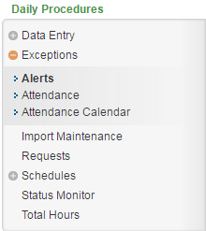
Alternatively, the user may also get to the alerts page by clicking the orange bubble that contains a number counter that will increase when an alert is received. It is located at the top left of the Time and Attendance system.

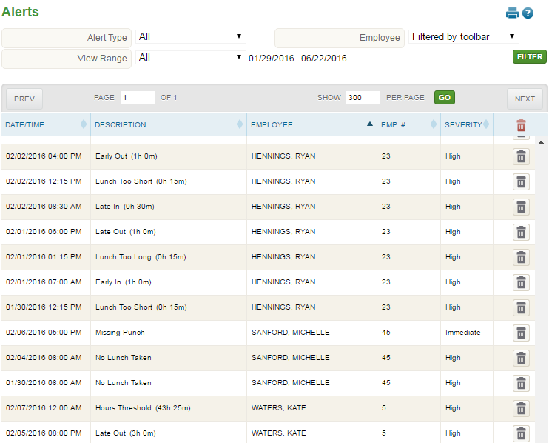
Reviewing the Alerts Page
1
2
3
4

- Page View – When multiple pages of alerts exist, the page to view can be chosen through this section
- Alerts List
  - Date/Time – Date and time of alert generation
  - Description – Alert type. For descriptions of common alerts, see the section titled “Alert Type Definitions.”
  - Employee – Employee who created the alert
  - Emp. # - Employee number of the employee who created the alert
  - Severity – Severity of the alert type. Severities can be changed to fit each individual company’s preferences.
  - Trash – This trash button (in the column header) deletes all alerts on the page. Alerts can be deleted one by one by using the grey trash cans within this column.
- Alert filtering – Filters the data on the page to a specified subset of information. To set a filter, select the filter option(s) and click Filter. The filtering options are below:
  - Alert Type – Type of alert
  - Employee – Employee who create the alert
  - View Range – Preset date ranges, or place in a start and end date within which the alert was generated.
- Additional Tools
  - Print – Prints data displayed on the page
  - Online Help – Launches Time and Attendance online help for the Alerts page

Alert Type Definitions
The Time and Attendance System has many possible alerts, each a result of different actions in the system. Below is a list of the most common alerts in alphabetical order.
- Absent - No punches on a scheduled work day within a specified number of minutes
- Approaching Premium - An employee works more than a specified number of hours in the same work week, but does not work more than the maximum number of hours defined
- Break Too Long - An employee takes longer than the defined duration for a paid break
- Consecutive Hours Worked - An employee works more than a specified number of hours in a single day
- Daily Hours Threshold - An employee works less than the minimum number of hours specified or greater than the maximum number of hours specified in a single day
- Early In - An In punch is recorded prior to the scheduled start time
- Excessive Breaks - An employee punches for more than the defined number of breaks per day
- Employee Approve/Reapprove – An employee’s timesheet requires an employee approval
- Late In - An In punch is recorded after the scheduled start time
- Lunch Too Long - An employee takes more than the defined duration for an unpaid lunch
- Lunch Too Short - An employee takes less than the defined duration for an unpaid lunch
- No Lunch Taken - No In From Lunch punch is recorded for the day
- Non-Scheduled Day - A punch is recorded for an employee on a day that they are not scheduled to work
- Missing Punch - An In punch exists without a matching Out punch, or an Out punch exists without a matching In punch
- Punches and Other Hours - A punch exists on the same day as an Hours record (i.e. PTO)
- Supervisor Approve/Reapprove – An employee’s timesheet requires a supervisor approval
- Suspicious Punch - The first punch of the day is an In For Lunch punch, or more than one In For Day punch exists during the same shift
- Weekly Hours Threshold - An employee works less than the minimum number of hours specified or greater than the maximum number of hours specified in a work week

Resolving Alerts
Each alert type has a different recommended action from the user. Instructions on how to review the alerts page and respond to each type appropriately are below.
- A user will be notified of the alert by an increased number in the orange bubble located at the top left of the system.
More critical alerts may also be sent to the user via e-mail.
- Most system setups will allow alerts to generate automatically. However, should the user wish to refresh the page, the Check for New Alerts and Check for New Alerts Next Period buttons can be clicked.
- Review each alert. Alerts can be sorted by column if the applicable column header is clicked. Alerts can also be filtered using the filter section at the top of the page.
- The action to take on each alert is dependent on the type of alert. Below is a list of common alerts that often require action with instructions for fixing them.
  - Missing Punch – Missing punches are the most critical to fix as approvals cannot be completed and payroll cannot be run if any missing punches exist in the system. A missing punch also means that the total hours for the employee are incorrect.
    - For information on how to fix a missing punch, see the “Fixing a Missing Punch” section of the “Punches” User Guide.
  - Absent – If an employee is marked as absent, one of the following should occur:
    - A punch or punches should be placed in for the day of the alert if the employee worked but did not punch.
    - An hours record such as Sick or PTO should be placed in to their Hours page for the day of the alert to account for their absence.
    - The employee’s assigned schedule should be updated if it was incorrect.
  - Suspicious Punch – If a Suspicious Punch alert exists, the Punch Type chosen for a punch on the day of the alert was incorrect. For example, this alert would be triggered if the first punch of the work day was an “In From Lunch”, instead of “In For Day”.
    - Review the Punches page for the date of the alert and update the Punch Type as needed.
  - Punches and Other Hours – When this alert is triggered, it is important to review the Hours page to ensure that what is listed for the day of the alert is appropriate. For example, if the employee had planned PTO listed in the Hours page but ended up working for the entire day instead, the PTO should be removed. If, however, the employee had PTO in the morning, but worked in the afternoon, no action would be needed for this alert.
    - Review the Hours page for the date of the alert and remove the Hours record if necessary.
  - No Lunch Taken – If this alert is listed, it is important to verify that the employee did not take a lunch if one should have occurred as it is possible that the employee forgot to punch In From Lunch after taking one.
    - If the employee forgot to punch In From Lunch, an In From Lunch punch should be manually placed into their timesheet.
- If action is taken to fix an alert, the alert will drop off of the list automatically once refreshed. If the alert is only informational and does not require action, the alert can simply be deleted using the adjacent Trash button. For more information on the common alert types, see the section titled “Alert Types.”

It is recommended that all alerts are reviewed on a daily basis; however, they must be resolved up by the end of each pay period.

Attendance
The Attendance Calendar page is used to track the attendance information of the employee selected in the main Employee drop down. Users who have access to this page can review employee trends in attendance exceptions, record reasons for the exceptions, excuse them, and keep track of resulting points tracking when applicable. Certain Pay Types entered on the Hours page can also be saved here, such as Sick or Vacation.

Navigating to the Attendance Page
- In the Main Navigation menu, open the Daily Procedures folder.
- Open the Exceptions subfolder.
- Click on the Attendance page.
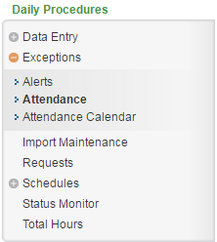

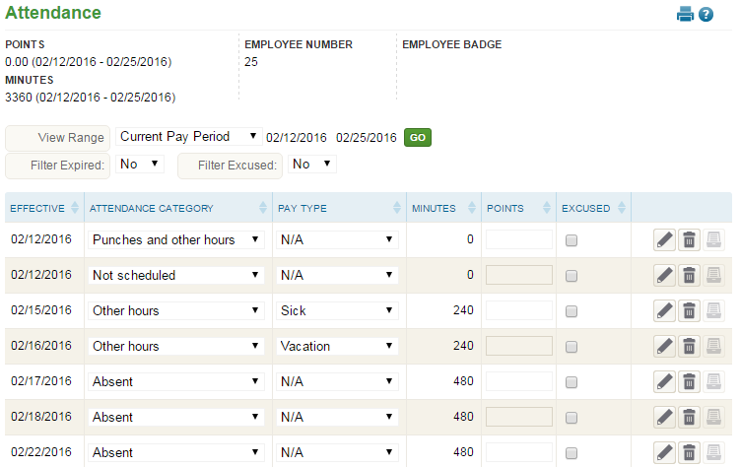
Reviewing the Attendance Page
1
2
3
5
4

- Summary Bar
  - Points – Total points for current pay period when a points policy is in place
  - Minutes – Totals minutes tracked within the minutes column
  - Employee Number – Assigned employee number
  - Employee Badge – Employee’s badge number if hardware clocks are in use
- Attendance Filtering – Filters the data on the page to a specified subset of information. To set a filter, select filter option(s) and click Go. Filtering options are below:
  - View Range – Select from a preset date range or place in a start and end date within which the request was sent
  - Filter Expired – Include or remove attendance records with expired points
  - Filter Excused – Include or remove attendance records marked as excused
- Attendance Records – Each attendance record from the employee is listed on this section of the page. For definitions of each field, see the section titled “Attendance Detail Definitions.”
- Unnamed Column – Buttons that allow additional interaction with the attendance record, including:
  - Edit – Edit details of the attendance record
  - Delete – Delete the attendance record
  - Audit Log – View details of the audit log associated with the attendance record
- Additional Tools
  - Print – Prints data displayed on the page
  - Online Help – Launches Time and Attendance online help for the Attendance page

Attendance Detail Definitions
Below is a list of the fields in alphabetical order that may be on the main Attendance page or within the Detail View pop-up window when editing or adding an attendance record. Access to these fields is dependent on each company’s set up.
- Attendance Category – Type of attendance record
- Attendance Comment – Comment to be associated with the attendance record
- Date/Time – Date and time that the attendance exception occurred
- Effective – Effective date of attendance record
- Effective Date – Effective date of attendance record
- Excused – Marks the attendance record as excused when checked
  - Points must be set to 0.00 to be disregarded with an excused attendance record.
- Excused Flag – Marks the attendance record as excused when checked
- Expiration Date – Expiration of points if a points policy is in place
- Minutes – Minutes associated with the attendance record
- Pay Type – Pay Type associated with the attendance record
- Points – Points associated with the attendance record if a points policy is in place
  - Points can be automatically applied based on company rules, or they can be manually added.
- Points Comment – Comment to be associated with points information if a points policy is in place
- Reason Code – Reason for attendance exception

Editing an Attendance Record
With the appropriate security, any item that displays on the main portion of the Attendance page can be edited simply by selecting and overwriting the data within the appropriate field. When finished, click Save.
Additional attendance information can be edited using the following steps:
- Click the Edit button of the attendance record to be edited.
The Detail View pop-up window opens.
- Adjust the field(s) as needed. At minimum, the Effective Date and Attendance Category fields must be completed. For definitions of each field, see the section titled “Attendance Detail Definitions.”
- Click Save.
Note: If an adjustment is made to points in a closed pay period, the running points total will be incorrect.

Deleting an Attendance Record
An attendance record can be deleted using the following steps:
- Click the Delete button of the attendance record to be removed.
A warning message will appear to confirm the deletion of the attendance record.
- Click OK.

Adding an Attendance Record
To add an attendance record:
- Click the Add button, located at the bottom left of the page.
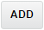
The Detail View pop-up window opens.
- Adjust the field(s) as needed. At minimum, the Effective Date and Attendance Category fields must be completed. For definitions of each field, see the section titled “Attendance Detail Definitions.”
- Click Save.

Attendance Calendar
The Attendance Calendar page is used to track the attendance information of the employee selected in the main Employee drop down, displayed in calendar form. Users who have access to this page can review employee trends in attendance exceptions, record reasons for the exceptions, excuse them, and keep track of resulting points tracking where applicable. Certain Pay Types entered on the Hours page can also be saved here, such as Sick or Vacation.
Navigating to the Attendance Calendar Page
- In the Main Navigation menu, open the Daily Procedures folder.
- Open the Exceptions subfolder.
- Click on the Attendance Calendar page.
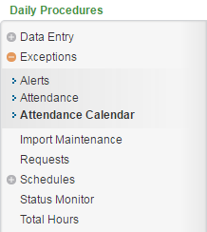

Reviewing and Using the Attendance Calendar Page
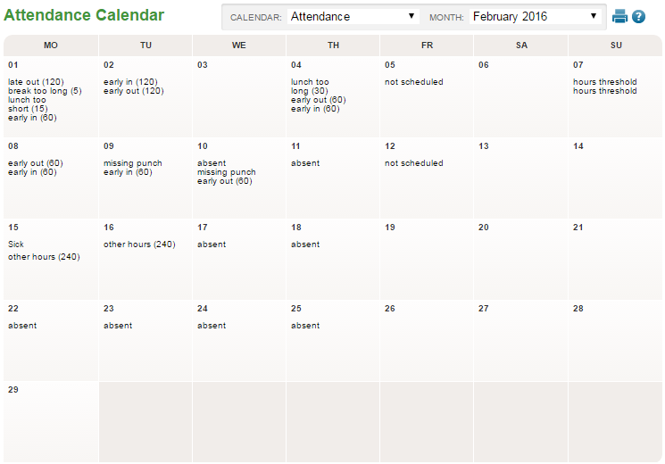
1
2
3

- Calendar of Attendance Records – Employee attendance records for the month selected
  - With proper security, you may click on the record to see and/or edit the information of the attendance record. For information on the contained in each record, see the section titled “Attendance Detail Definitions.”
- Page View – Selection of attendance calendar and month.
  - Calendar – Attendance calendar if multiple exist
  - Month – Calendar month
- Additional Tools
  - Print – Prints data displayed on the page
  - Online Help – Launches Time and Attendance online help for the Time Off Calendar page

Frequently Asked Questions

What is the difference between the Alerts and Attendance pages?
The alerts page displays the initial notification of an item that needs user attention. The items here should be fixed or deleted on a daily or, at the least, pay period basis. The Attendance pages track certain items from the alerts page long term, as well as allowing for additional information, editing of each exception, and points tracking. Certain Pay Types entered on the Hours page can also be placed here, such as Vacation, Sick, and Bereavement.

Is it possible to see all employees’ attendance information at once in the Attendance pages?
The Attendance Calendar and Attendance pages can only show the attendance records of one employee at time. However, the user may run the Attendance – Attendance Details report to see many employees’ attendance records at once.

